OCEANA COUNTY 4-H SMALL MARKET
RABBIT RECORD BOOK – `
(for ages 8 and up)

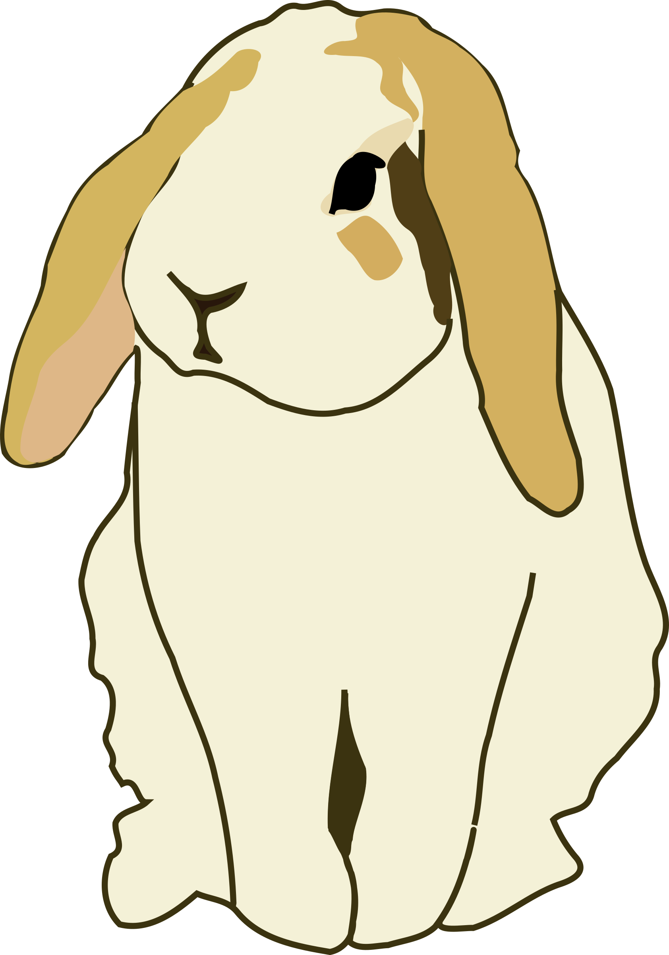
As a member of the 4-H Small Market Animal Project, you are required to submit your records as part of an educational project notebook in order to show your animal at the Oceana County Fair. This notebook must be shown to the Rabbit Superintendent or designated Small Market Weighmaster at the time of weigh-in and then entered by you in the Educational Notebook Division at the Oceana County Fair on Entry Day.
AGE: __________
The age you enter depends on how old you were on January 1, 2025.

NUMBER OF YEARS IN PROJECT: __________

Use this sheet as the first page of your project record book. Fill it out completely.
Please print or type neatly.

Name _______________________________________________________________________

4-H Club Name ______________________________________________________________

Breed, Variety and Age of Doe: _______________________________________________
Breed Variety Age

How long have you owned the Doe: ____________

Breed, Variety and Age of Buck used: _________________________________________
Breed Variety Age

Do you own the buck? ____ Yes _____ No If not the owner of the buck, what, if any, arrangements were made for his services:

____________________________________________________________________________

____________________________________________________________________________

Date of Breeding: ____________________ Date of Kindling: ___________________

No. of days of Gestation ______________ No. of live kits: ____________________

No. of non-live kits: ___________________


JUDGE’S SCORE/COMMENT SHEET

(PLEASE DO NOT REMOVE, PLACE THIS SHEET IN SHEET PROTECTOR OR GLUE TO COVER). This sheet must be keep free to the judge to write their comments.

This sheet should help each junior market member understand their ribbon placing.

A. Specific educational value or worth

___ All questions were answered completely

___ All calculations were correct

___ Calculations were incorrect

___ Questions were not completely answered

___ Questions were not answered (missed questions)

B. Notebook contains all project records

___ Notebook contained all project records and were fully completed

___ Notebook contained additional project related information (research

materials etc.)

___ Project records were incomplete

___There was no additional project related information

C. Accuracy, neatness and general appearance

___Notebook was neat in appearance (typed/hand printed)

___ Notebook pages were clean and stain free

___Notebook pages were in order and complete

___Notebook pages were out of order and missing pages

___Notebook was difficult to read and messy

___Notebook had wrinkled and stained pages

Other Comments:

_____________________________________________________________________________________

_____________________________________________________________________________________

__________________________________________________________________
2025-SMA Rabbit Notebook Page 2

OBJECTIVES

- Develop desirable work habits, sportsmanship, and ability to cooperate and express ideas through participation in projects, discussions, method demonstrations, judging teams, and exhibits.
- Experience the pride and responsibility of leasing/owning and caring for rabbits.
- Learn how to feed, fit, show, breed and raise rabbits.
- Learn proper handling procedures to prevent injuries to 4-H members and their rabbit projects.
- Appreciate and use scientific information in rabbit production and marketing.
- Improve knowledge of grading, marketing and merchandising of rabbits and rabbit products.
- Improve knowledge of the nutritive value of rabbit meat.
- Learn the importance of the rabbit industry to the local, state, and national economies.
- Acquire information on the opportunity that rabbits offer as a career.
This record book is part of your Small Market Rabbit project. By keeping records up-to-date you will be able to see how much progress you make as you set goals and work to accomplish them. Write or type neatly and clearly. Please keep the pages in order. Feel free to add extra pages at the end of your notebook.

SCORING CRITERIA
The following breakdown will be used during the judging process of all market livestock notebooks.

A. Specific educational value or worth 30%
B. Creative way of showing what has been learned 10%
C. Notebooks contains all project records 50%
D. Accuracy, neatness and general appearance 10%

The Oceana County 4-H Small Market Animal Committee encourages 4-H Leader and parent assistance with your project and project notebook.

If you needed extra help in filling out your notebook please have whoever helped sign below that the answers are YOUR answers and that they assisted you in the writing of the answers and understanding of the questions only. The judges prefer to see the youth’s handwriting over the adults in most cases.

(signature of person helping with writing if needed)
2025 SMA Rabbit Notebook Page 3

ANIMAL CARE AND MANAGEMENT

Your project requires regular care and management. List the things necessary to take care of your project animal(s).

Include the following:
- Feeding and watering practices
- Grooming (clipping, toenail trimming, etc.)
- Health practices and medicines
- General Management (cleaning living area, etc.)

Daily- Things done one or twice a day
Weekly- Things done once or twice a week
Monthly- Things done once a month
Yearly- Things done one time or occasionally throughout the year
2025 SMA Rabbit Notebook Page 4

MARKETING

One of the most important parts of any market animal project is marketing; this is how you get someone to come to the auction to buy your animal. It may include things such as writing letters and talking to possible buyers.

- What did you do to market your animal?
- If you had a market project in the past what did you do differently this year?

______________________________________________________________________________

______________________________________________________________________________

______________________________________________________________________________

______________________________________________________________________________

______________________________________________________________________________

AGE & WEIGHT CHART

Date of Weaning: _________________ Age at Time of Weaning: _______________

Weight at time of Weaning: Rabbit No. 1 ______________
(Record in Lbs. /Oz)
Rabbit No. 2 ______________

Rabbit No. 3 ______________

Final Weight: Rabbit No. 1 ______________
(Record in Lbs. /Oz)
Rabbit No. 2 ______________

Rabbit No. 3 ______________

Total Weight of Market Rabbit Pen: ______________ (TW)

* Final weights may be estimated depending on Covid restrictions in summer of 2021.

2025 SMA Rabbit Notebook Page 5
(B)
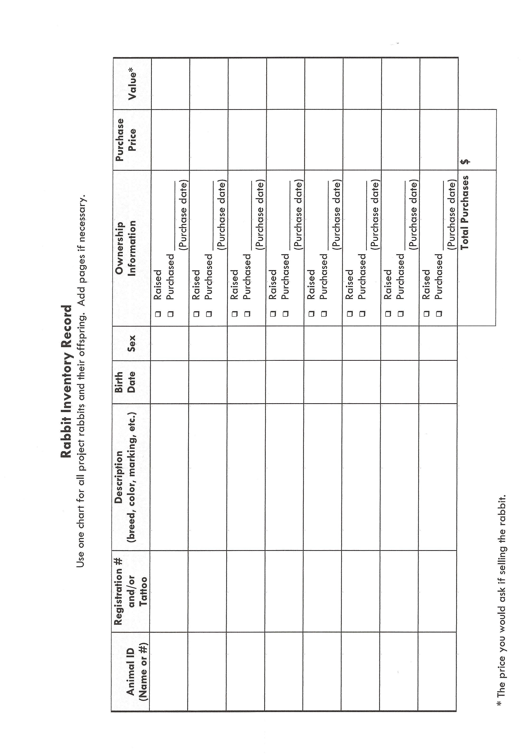
2025 SMA Rabbit Notebook Page 6
MISCELLANEOUS INCOME

List any income received. Examples: Selling additional offspring, fur, premiums from shows, etc.) If none just write NONE.

Date | Description | Cost $
 | Total Miscellaneous Income (A) | $

EXPENSES- INVENTORY, EQUIPMENT & SUPPLIES

At the beginning of the 4-H year take an inventory of what equipment & supplies are on hand.

Add new equipment or supplies you purchase to the list. Estimate a cost value for any shared equipment (ex: 1 set of nail clippers shared between 3 members $21.00÷3 = $7.00 each.

Amount & Kind | Already Owned  Or Purchased | Purchase Price
Example: rabbit pen | Already Owned
1 feed bowl | Purchased | $3.00
 | Total Equipment & Supplies (C) | $

2025 SMA Rabbit Notebook Page 7

FEED RECORDS & EXPENSES

Keeping good feed records is important. Good records show your expenses for feed and what kind of feed you use for your project. A good practice is to enter your feed expenses when you buy feed. At the end of each month, total each kind of feed used and its cost and record the information below. Home-raised feeds should be valued at market price- what it can be sold for.
Type and Cost of Feed Used

Date of  Purchase | Amount Purchased (lbs.) | Type of feed  (grain, mix, hay, forage pellets, salt, mineral supplement) | Cost  or  Value
Total Pounds |  | Total Feed Cost (D) | $

2025 SMA Rabbit Notebook Page 8

MISCELLANEOUS EXPENSES OR FEES

List any expenses that do not fit into one of the previous categories.
Examples: Breeding Fees, Registration Papers, Medications,
Vet Fees, etc. If none write NONE.

Date | Description | Cost $
 | Total Miscellaneous Expenses (E) | $

PROJECT FINANCIAL SUMMARY

Grand Total of All Expenses (B,C,D,E): $ ___________(TE) (from pgs. 5, 6, 7 & 8)

Total Expenses (TE) – Any Income (A) = $ __________________ (PE) Project Expense

______________ ÷ ________________ = ___________________________________
Project Expense (PE) Final Weight (FW) Break Even Price (BE)
(of pen of 3) (total cost per pound to raise your animal)

* Final weight may need to be estimated depending on Covid 19 restrictions.

** The breakeven price is the price that you need to get at the
Small Market animal auction in order to not
lose money on your market project. **

2025 SMA Rabbit Notebook Page 9

RABBIT BREEDING & LITTER RECORD

 |  |  |  |  | Number  Surviving | of  Kits |  | Kits | Kept
Name & Number of Dam | Name & Number of Sire | Date Bred | Date Kindled | Total Number in Litter | Bucks | Does | Date Weaned | Buck | Does
Ex: Peaches VA3 | Spot/VA8 | 3/19/14 | 4/20/14 | 5 | 2 | 2 | 6/1/14 | 0 | 2

PROJECT PROGRESS AND MANAGEMENT REPORT

Please answer the following questions with at least 20-30 words each.

1. Explain how you trained and prepared your animal(s) for show, both market
and your showmanship animal.

____________________________________________________________________________________________________________________________________________________________________________________________________________________________________________________________________________________________________________
___________________________________________________________________________

2025 SMA Rabbit Notebook Page 10

2. What part of your project was the most fun? _______________________________
____________________________________________________________________________
____________________________________________________________________________
____________________________________________________________________________
____________________________________________________________________________

3. Which part was the hardest? ______________________________________________

____________________________________________________________________________
____________________________________________________________________________
____________________________________________________________________________
_____________________________________________________________________________

4. Would you do the market rabbit project again? ______________________
Why or why not? ______________________________________________________
__________________________________________________________________________________________________________________________________________________________________________________________________________________________________________
______________________________________________________________________________
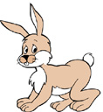

2025 SMA Rabbit Notebook Page 11

 |  |  |  |  |  |  |  |  |  |  |  |  |  |  |  |  |  | 10
 |  |  |  |  |  |  |  |  | 1
 |  |  |  |  |  |  |  |  |  |  | 9 |  |  |  |  |  |  | 2
 |  |  |  | 11 |  |  |  |  |  |  |  |  |  |  | 3
7 |  |  |  |  |  |  | 4
WORD BANK

BLEMISH MANGE
BREED MITE
BUCK MASTITIS
CHOPPED MOLT
DEWLAP MUZZLE
DOE PELT
JUNIOR SENIOR
KINDLE TATTOO
MALOCCLUSION VARIETY

 | 8. |  |  |  |  | 5
 | 6
ACROSS:
1. Teeth having the lower incisors extending in
front of the upper incisors or meeting with no
overlap.
2. An intact female rabbit
3. A small insect that often infests rabbits. A
disqualification from competition.
4. Any defect or fault which detracts from the
appearance.
5. A rabbit 6 months of age or over in those
breeds having 4 showroom classes. A rabbit
8 months of age or over in breeds having 6
showroom classes.
6. A body type fault in which there is an abrupt
and sharp vertical fall from the top of the hip
to the tail. Not well filled out & rounded.
7. A skin disease caused by parasitic mites. May
be characterized by itching, lesions, scabs
and loss of hair. A disqualification from
competition.

DOWN:
1. The lower part of the face and nose of the
rabbit.
4. A class of domestic rabbits that reproduces
itself with distinctive characteristics, such as
fur, markings, shape & size.
8. An intact male rabbit.
9. A rabbit less than 6 months of age.
10. The act of giving birth by rabbits.
11. A pendulous fold of loose skin that hangs
From The throat, it is common in does. A
disqualification from competition in some
breeds.

2025 SMA Rabbit Notebook Page 12

LABEL THE PARTS OF A RABBIT (Age 9 and up Complete)
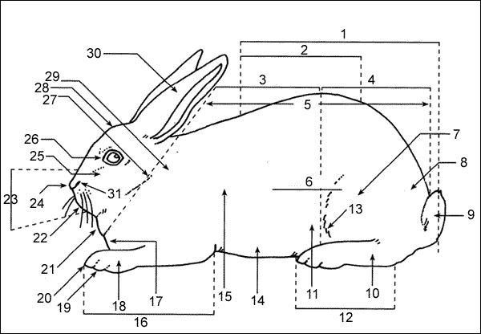

2025 SMA Rabbit Notebook Page 12

1. | 16.
2. | 17.
3. | 18.
4. | 19.
5. | 20.
6. _ | 21.
7. | 22.
8. | 23.
9. | 24.
10. | 25.
11. | 26.
12. | 27.
13. | 28.
14. | 29.
15. | 30.

2025 SMA Notebook Rabbit Page 13

Label the Cuts of Meat (age 12 and up)

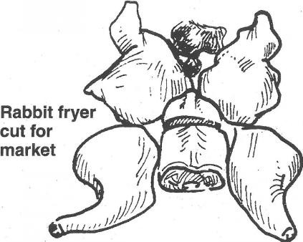
7
6
4
5Photo taken from 4-H Skills for Life Rabbit book 2
1
3
2

1. ________________________ 2. ________________________

3. ________________________ 4. ________________________

5. ________________________ 6. ________________________

7. ________________________

2025 SMA Notebook Rabbit Page 14

Place This Class of Market Rabbits
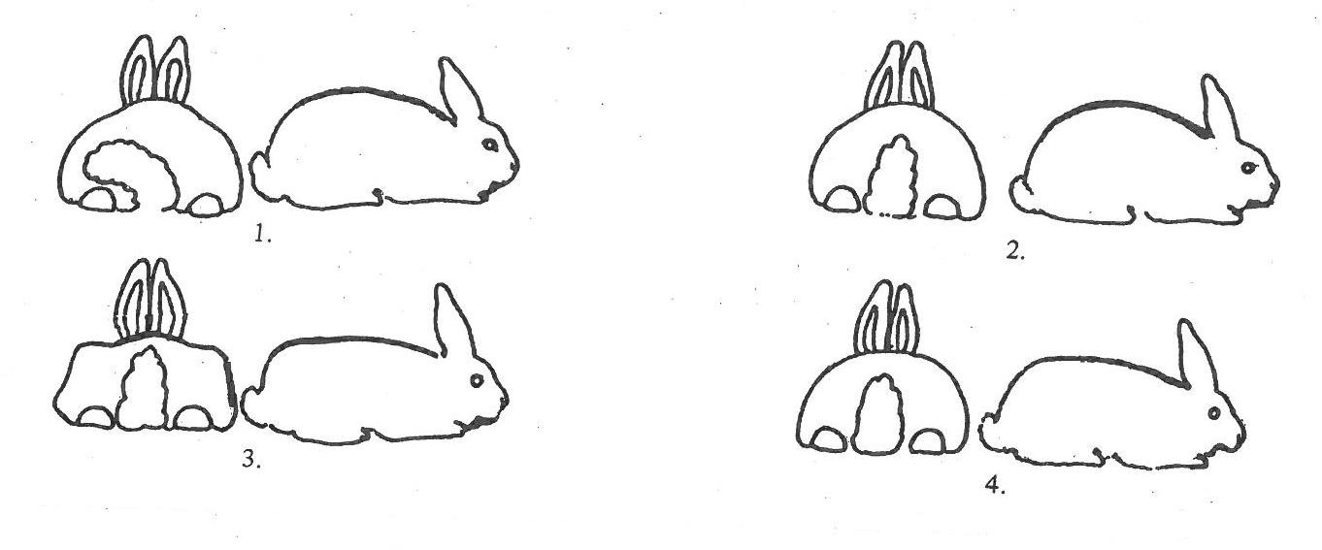
Photos from Extension Bulletin AS/R 109.12
When selecting your entry of single fryers, roasters or stewers you are looking for the rabbit that most closely conforms to the required weight of that category. Understanding that the meat type is key you will select the rabbit that is full, solidly fleshed and round; an animal that will butcher with the maximum amount of meat with minimum offal. Well-developed shoulders are indicative of meat carrying properties as are a wide and deep loin and thick hindquarters. Once you have selected the animals that best meet those requirements you will then select for firmness of flesh, superiority of conditions and quality of fur. Domestic Rabbits Nov Dec

Class Placings

1._________ 2. _________

3. ________ 4. _________

2025 SMA Notebook Rabbit Page 15

Diseases (age 15 and up complete)

- List the names of two (2) bacterial diseases of rabbits, the signs, and tell what treatment(s) you should use to rid your rabbits of these diseases.
Bacterial Disease | Signs | Treatments
1. | _____________________________________  _____________________________________ | ______________________________________  ______________________________________
2. | _____________________________________  _____________________________________ | _____________________________________  _____________________________________

- List the names of two (2) parasitic conditions of rabbits, the signs, and tell what treatment(s) you should use to rid your rabbit of these parasites.
Parasitic Condition | Signs | Treatments
1. | _____________________________________  _____________________________________ | ______________________________________  ______________________________________
2. | _____________________________________  _____________________________________ | _____________________________________  _____________________________________

2025 SMA Notebook Rabbit Page 16

Diseases (age 15 and up complete) Continued

- List the names of two(2) non infectious conditions, the signs, and tell what treatment(s) you should use to rid your rabbit of these noninfectious conditions.
Bacterial Disease | Signs | Treatments
1. | _____________________________________  _____________________________________  _____________________________________ | ______________________________________  ______________________________________  ______________________________________
2. | _____________________________________  _____________________________________  _____________________________________ | _____________________________________  _____________________________________  _____________________________________

The 4-H Pledge
(fill in the blanks)

I Pledge:
My HEAD to clearer _______________________________,
My HEART to greater ______________________________,
My HANDS to larger ________________________________, and
My HEALTH to better ________________________________,
For my __________________________, my _________________________________,
My __________________________, and my __________________________

The 4-H Mottos is: ______________________________________________.

2025 SMA Notebook Rabbit Page 17

MY 4-H STORY

Interesting things that happened to me and my animal this year, challenges, highlights of my year or anything else I would like to share about my overall 4-H experience.

POTENTIAL BUYERS NAMES

As part of your 4-H Small Market Livestock Project, you must personally contact at least three potential buyers before the Oceana County Fair. You are encouraged to seek two new buyers that have not been asked or submitted before. You also must have at least three different buyers than those of your siblings in the market livestock project. Please confirm with your buyers their accurate mailing address (example: post office box vs. a street address). The information on page 14 must be completed and taken to the Oceana County MSU Extension Office on or before the due date where it will be copied and used to send out letters to your potential buyers. This page will remain in your notebooks. This is a Market Livestock Committee rule. Failure to comply will result in not being able to sell your animal in the 4-H Market Livestock Sale.

Page 19 Date: _______________
2025 SMA Market Rabbits Staff: _______________

SMALL MARKET RABBIT
POTENTIAL BUYER’S LIST (ages 8 & up)

Name______________________________ Club_________________________
Please print business names and complete addresses clearly.

  - Contact Name ____________________________________________________

Business Name ____________________________________________________

Mailing Address _________________________City_________________Zip_____

Phone _______________________ After Hours Phone______________________
Mailing Preference (Please Check One): Email ____ Postal Delivery ____

Email ____________________________________________________________

Signature__________________________________________________________

2. Contact Name ____________________________________________________

Business Name ____________________________________________________

Mailing Address _________________________City_________________Zip_____

Phone _______________________ After Hours Phone______________________
Mailing Preference (Please Check One): Email ____ Postal Delivery ____

Email ____________________________________________________________

Signature__________________________________________________________

3. Contact Name ____________________________________________________

Business Name ____________________________________________________

Mailing Address _________________________City_________________Zip_____

Phone _______________________ After Hours Phone______________________
Mailing Preference (Please Check One): Email ____ Postal Delivery ____

Email ____________________________________________________________

Signature__________________________________________________________

(Must be stamped by the MSU Extension Office)
2025 SMA MARKET RABBITS PAGE 20

PICTURES OF YOUR PROJECT
(Please use this page for your project pictures. Add additional pages if
you would like. The judges appreciate you labeling the pictures so
they know what the picture shows.)

CLUB POINTS
JUNIOR MARKET/SMALL ANIMAL ASSOCIATION PROJECT
ATTENDANCE RECORD

MEETING NAME | LOCATION | DATE | POINTS | SIGNATURE OF LEADER
Please note: This form must be included with your record notebook and turned into the weigh master on entry day of the Fair. You need to accumulate nine (9) points to be allowed to sell your animal. Six (6) of these nine (9) points must come from club meetings. Three (3) nonclub points must come from other types of meetings (example: clinics, shows, workshops, fair clean-up and/or county-wide awards).

NON-CLUB POINTS

JUNIOR MARKET/SMALL MARKET ANIMAL ASSOCATION PROJECT
ATTENDANCE RECORD
(this must be filled out when presenting for signatures at the office

MEETING NAME | LOCATION | DATE | POINTS | SIGNATURE OF LEADER, SUPERINTENDENT OR MSU STAFF
Please note: This form must be included with your record notebook and turned into the weigh master on entry day of the Fair. You need to accumulate nine (9) points to be allowed to sell your animal. Six (6) of these nine (9) points must come from club meetings. Three (3) nonclub points must come from other types of meetings (example: clinics, shows, workshops, fair clean-up and/or county-wide awards).

